# User-Defined Functions in Sakila: Filtered by Held by Customer

Question Screenshot:

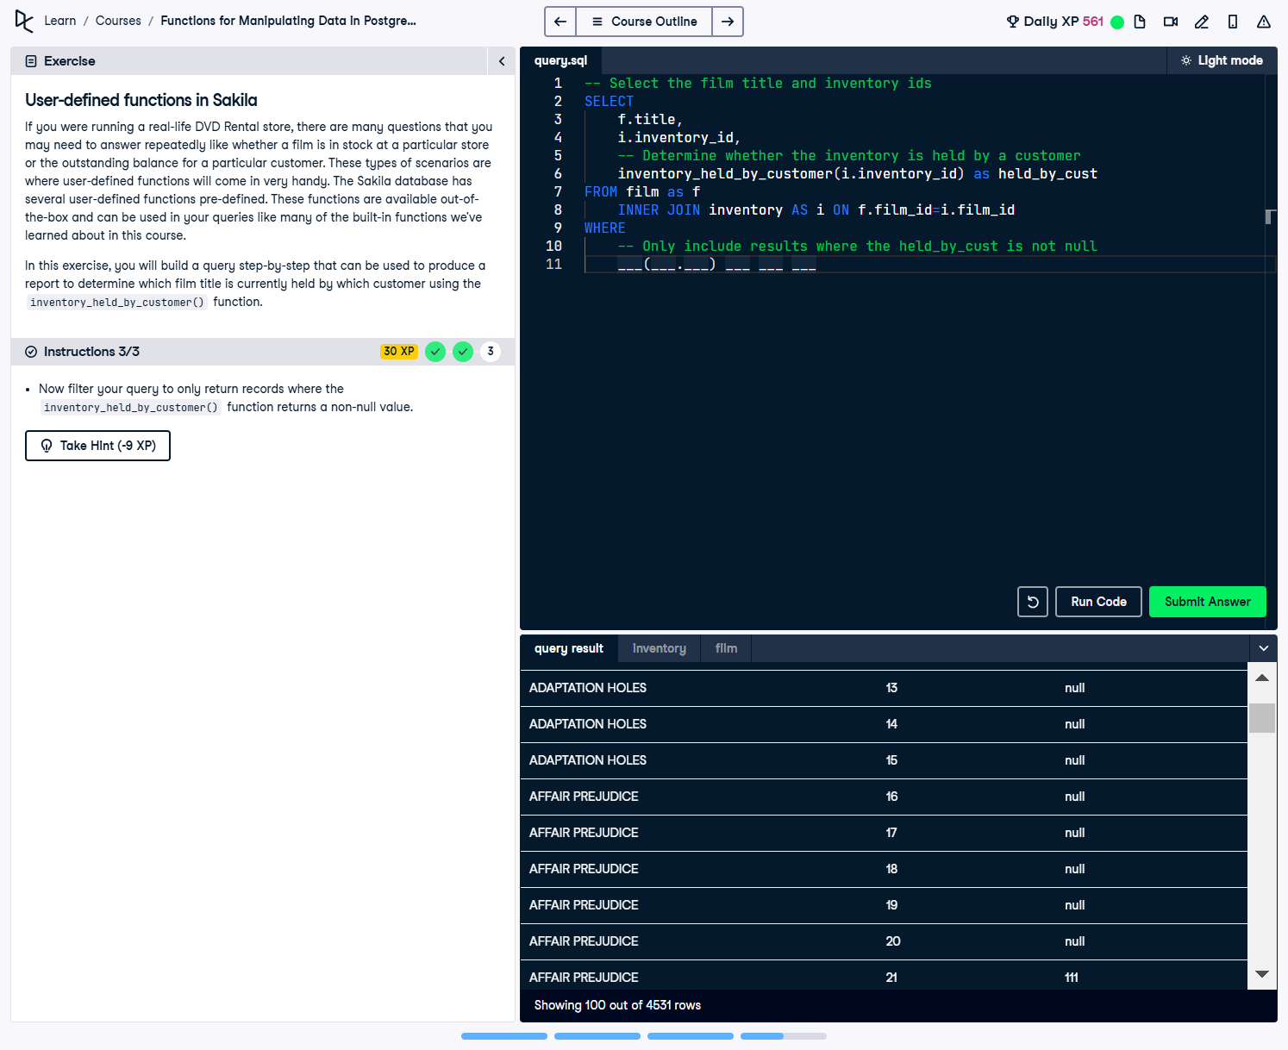

Question:  
If you were running a real-life DVD Rental store, there are many questions that you may need to answer repeatedly like whether a film is in stock at a particular store or the outstanding balance for a particular customer. These types of scenarios are where user-defined functions can come in very handy. The Sakila database has several user-defined functions pre-defined. These functions are available out-of-the-box and can be used in your queries like many of the built-in functions we’ve learned about in t...  
  
Instruction:  
1. Select the title and inventory_id columns from the film and inventory tables in the database.  
2. Perform an INNER JOIN on the inventory and film tables using the appropriate key.  
3. Filter your query to only return records where the inventory_held_by_customer() function returns a non-null value.

Answer:

-- Select the film title and inventory ids  
SELECT   
 f.title,  
 i.inventory_id,  
 -- Determine whether the inventory is held by a customer  
 inventory_held_by_customer(i.inventory_id) AS held_by_cust  
FROM film AS f  
 INNER JOIN inventory AS i ON f.film_id = i.film_id  
WHERE   
 -- Only include results where the held_by_cust is not null  
 inventory_held_by_customer(i.inventory_id) IS NOT NULL;

Explanation:

1. SELECT f.title, i.inventory_id: Retrieves the title and inventory ID of each film.  
2. inventory_held_by_customer(i.inventory_id): Uses a user-defined function to check if the inventory item is currently held by a customer.  
3. INNER JOIN: Joins the film table with the inventory table based on the film_id key.  
4. WHERE inventory_held_by_customer(i.inventory_id) IS NOT NULL: Filters the results to show only inventory items currently held by a customer.